BUILT A CHATBOT AMAZON LEX



 Building a Smart Chatbot with Amazon Lex: Unleashing the Power of Conversational AI   
This new project that leverages Amazon Lex to create a powerful, scalable chatbot that can interact with users in natural, meaningful way.

Log in to your AWS account.

Navigate to Amazon Lex (type lex into the search bar of your console).

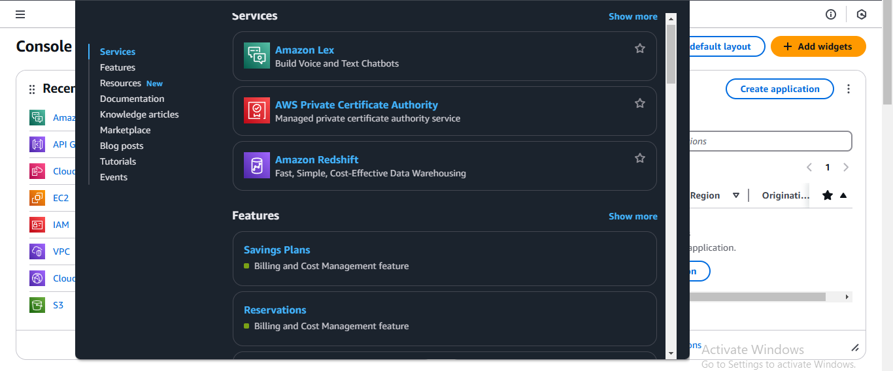

Select Create bot.

Select Create a blank bot.

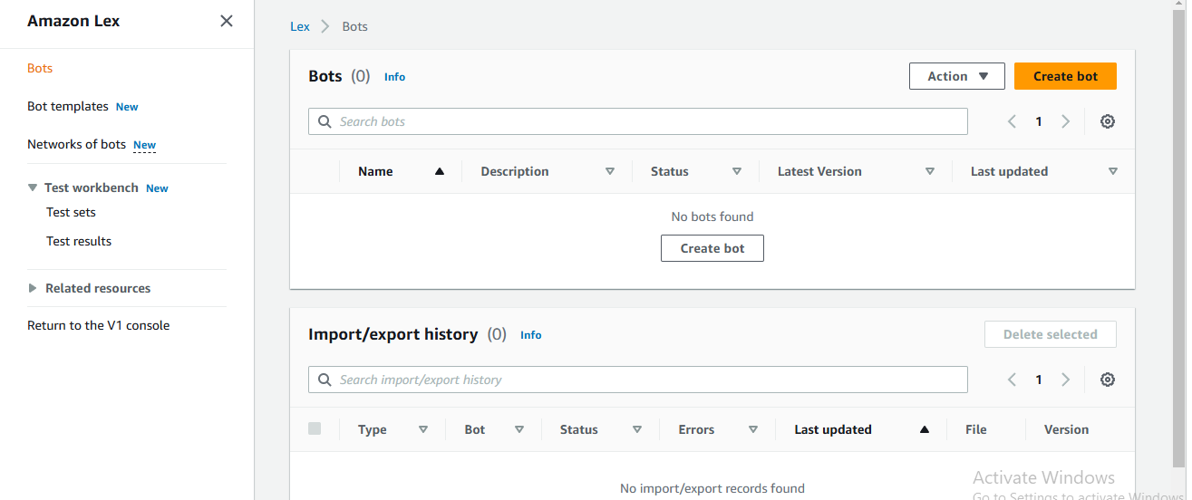

For Bot name, enter Bankerbot

For Description, enter Banker Bot to help customer check their balance and make transfers.

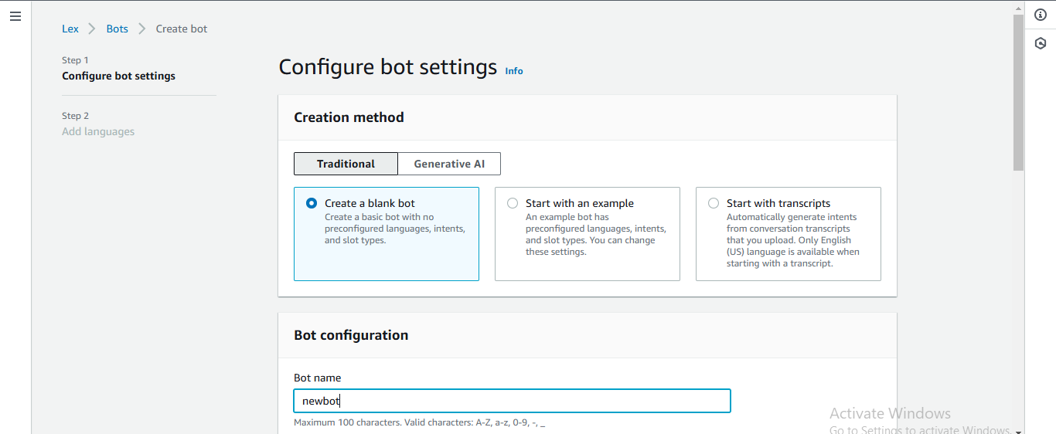

Under IAM Permissions, select Create a role with basic Amazon Lex permissions.

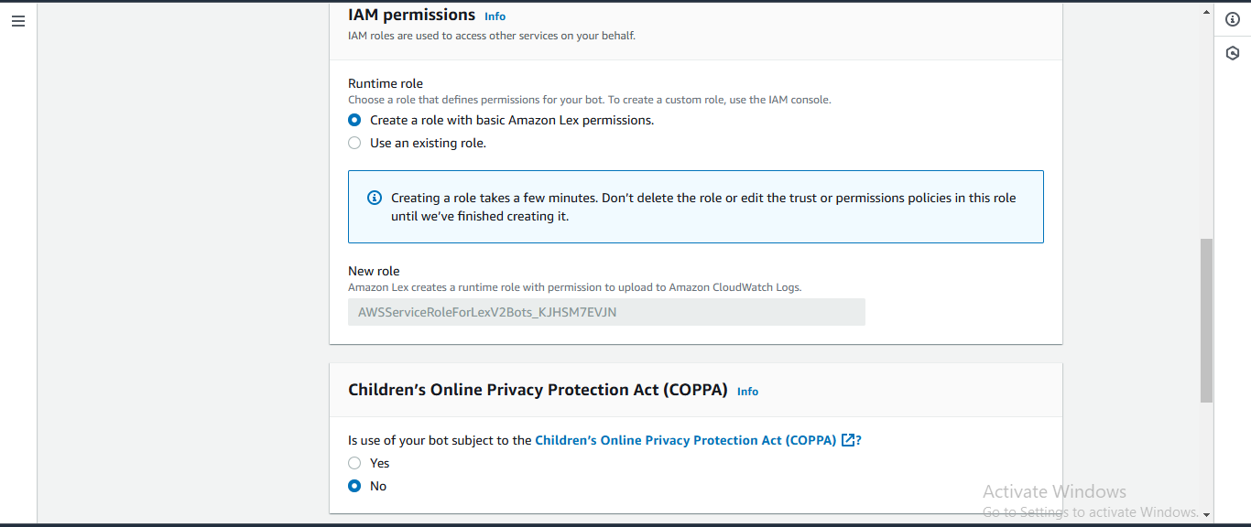

Under Children’s Online Privacy Protection Act (COPPA), Select No.

Under Idle session timeout, keep the default of 5 minutes.

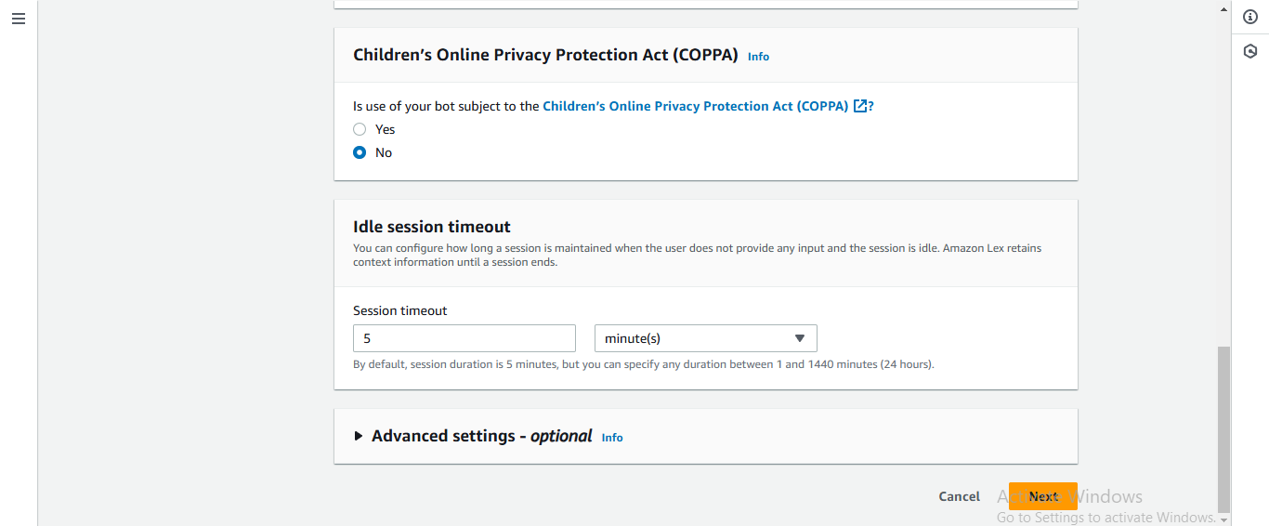

Select Next.

Keep the language as English so you can explore Lex’s full set of features in this project.

Under Voice interaction, click on the dropdown that says Danielle.

For Intent classification confidence score threshold, keep the default value of 0.40.

Select Done

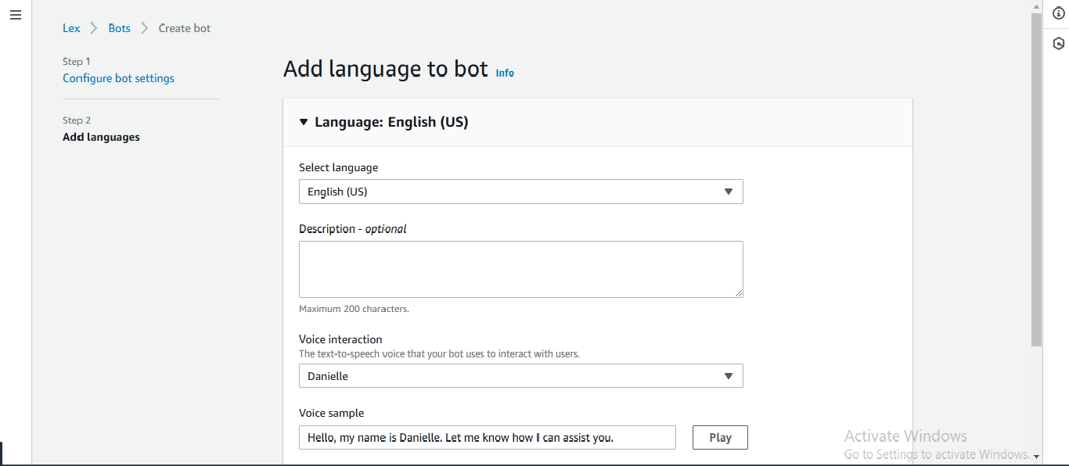

When your bot is created, you will automatically see a page called Intent: NewIntent.

Under Intent details, enter WelcomeIntent for the Intent name.

Add the description Welcoming a user when they say hello.

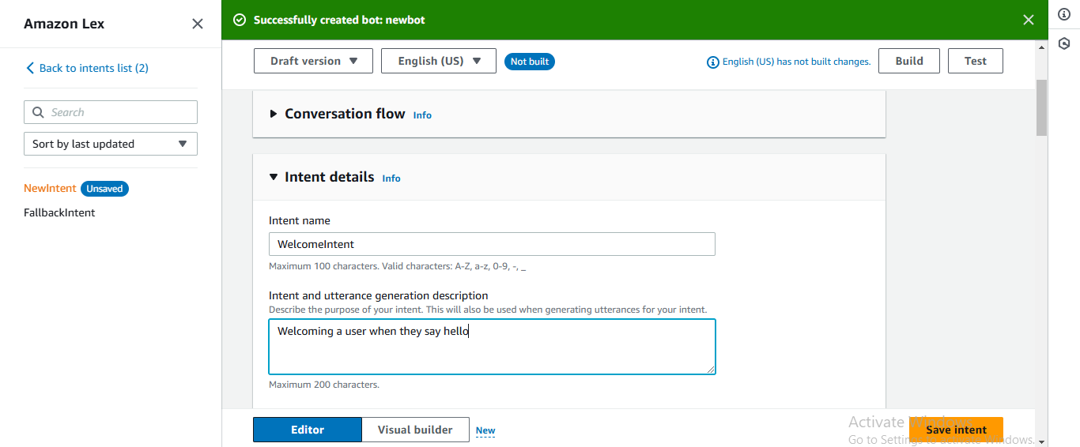

Scroll down to the Sample utterances panel.

Click the Plain Text button

Copy the text below, which represent the user inputs (called utterances) that will trigger this input, and paste it into the text window:

Hi

Hello

I need help

Can you help me?

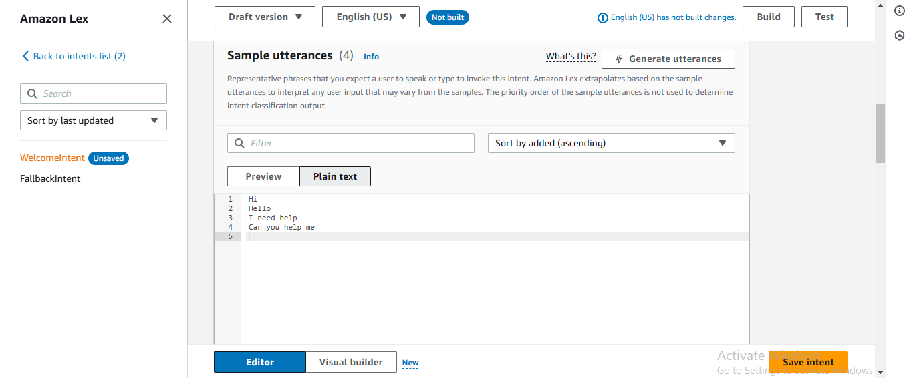

Click back to the Preview button to see these utterances in chat form.

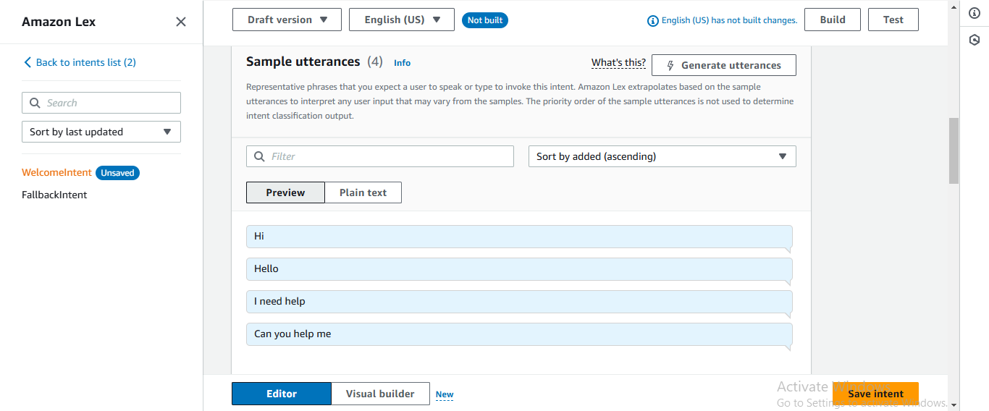

Scroll down to Closing response, and expand the arrow for Response sent to the user after the intent is fulfilled.

In the Message field, enter the following message: Hi! I’m BB, the Banking Bot. How can I help you today?

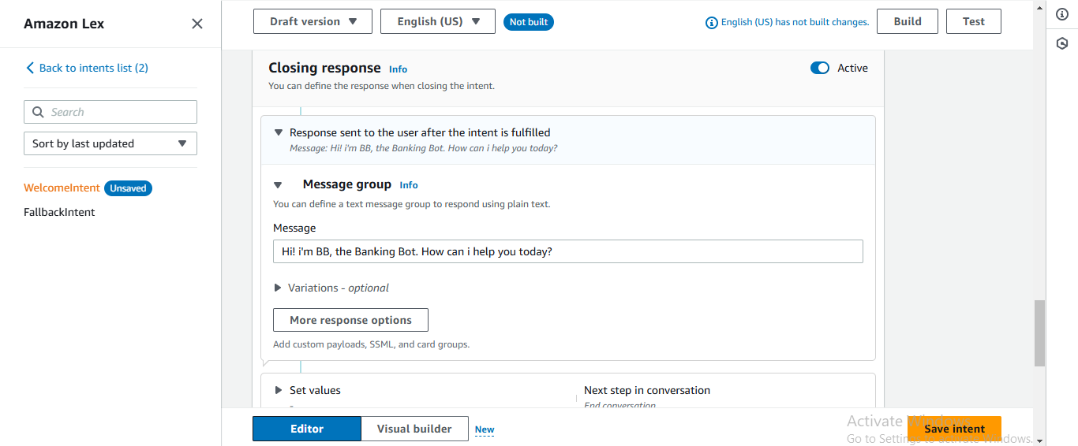

Choose Save intent.

Choose Build, which is close to the top of the screen.

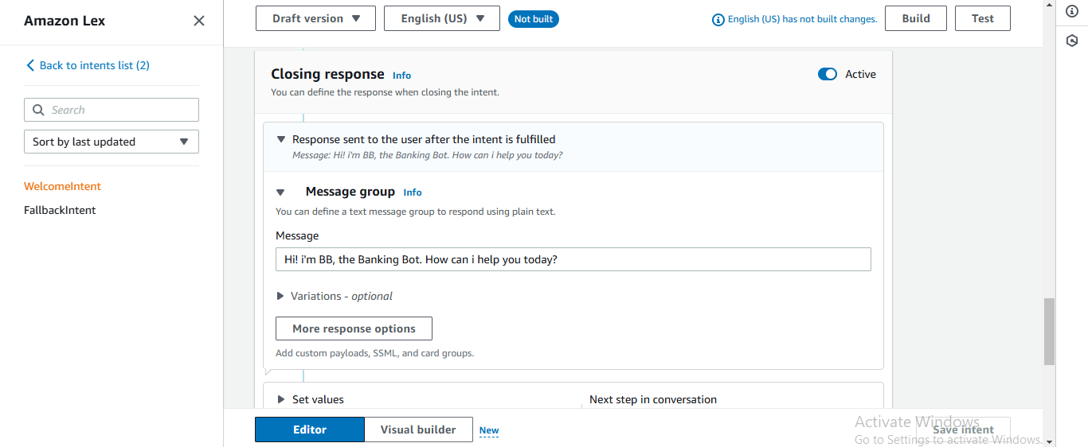

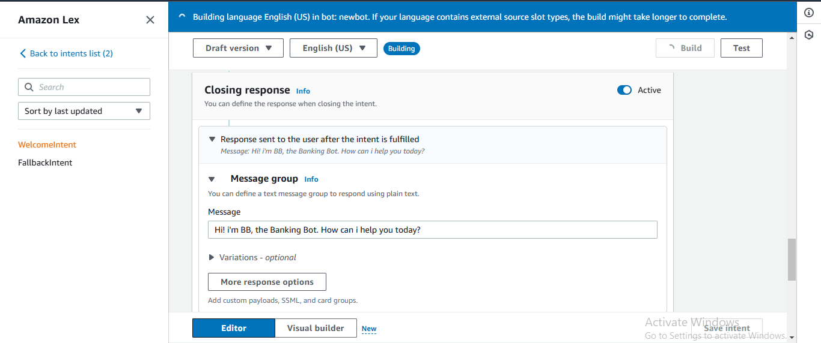

Choose Test.

The following dialog will pop up, and you can interact with the bot by entering your opening message.

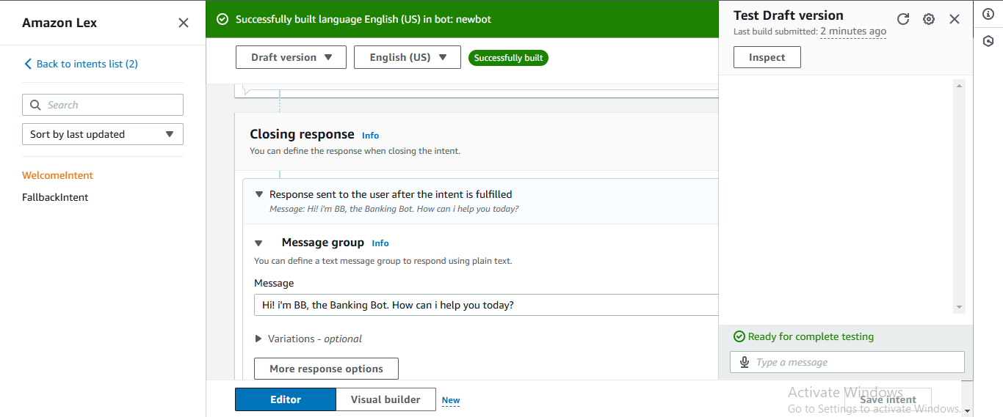

Trying saying Hello, it gives a response.

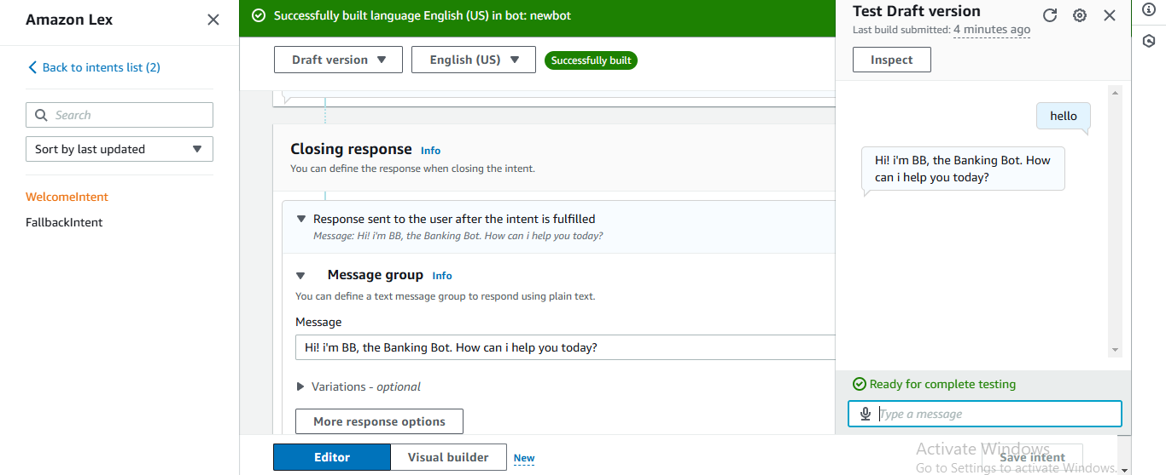

Now try different phases and see what comes up!

The ones that you have literally defined in your Utterances section will definitely work.

But what about other Utterances?

Since we have an intent classification confidence score of 0.40, other phrases with similar intents to the ones we’ve defined could work too.

Test these:

Help me

Hiya

How are you

Good morning

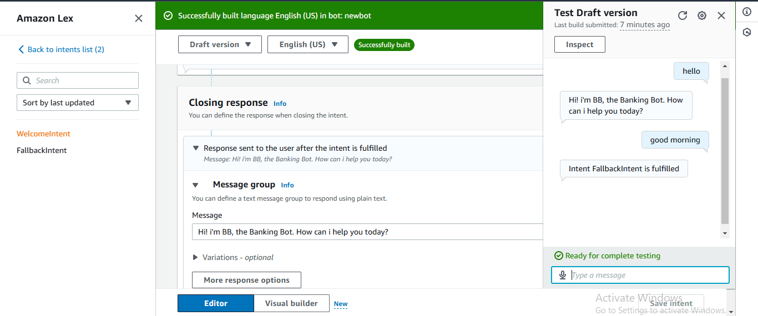

So our chatbot will “Intent FallbackIntent is not fulfilled” when it doesn’t understand the user.

In this step, we will customize FallbackIntent to send user-friendly messages.

In your left hand navigation panel, choose FallbackIntent.

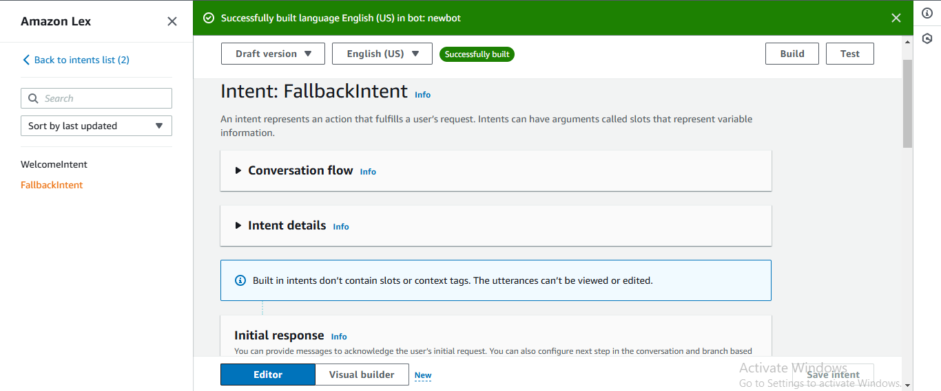

The default FallbackIntent message you saw just now (“Intent FallbackIntent is fulfilled”) can be a little confusing.

Scroll down to Closing responses.

Expand the arrow for Response sent to the user after the intent is fulfilled.

In the message field, add the following text: Sorry I am having trouble understanding. Can you describe what you’d like to do in a few words? I can help you find your account balance, transfer funds and make payment.

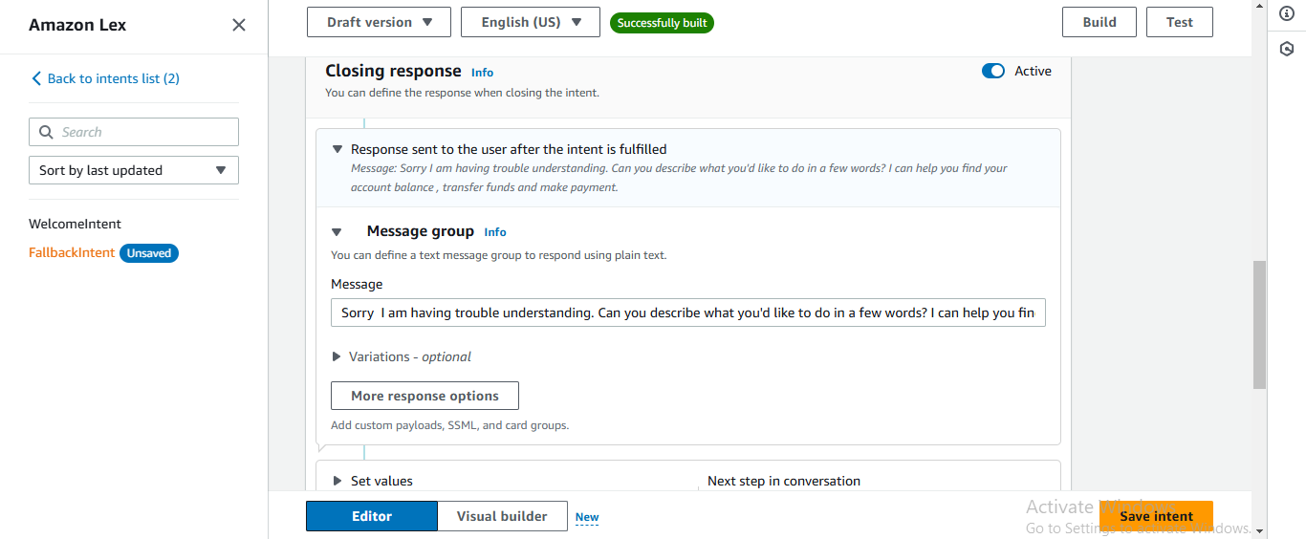

Choose Save intent.

Choose build.

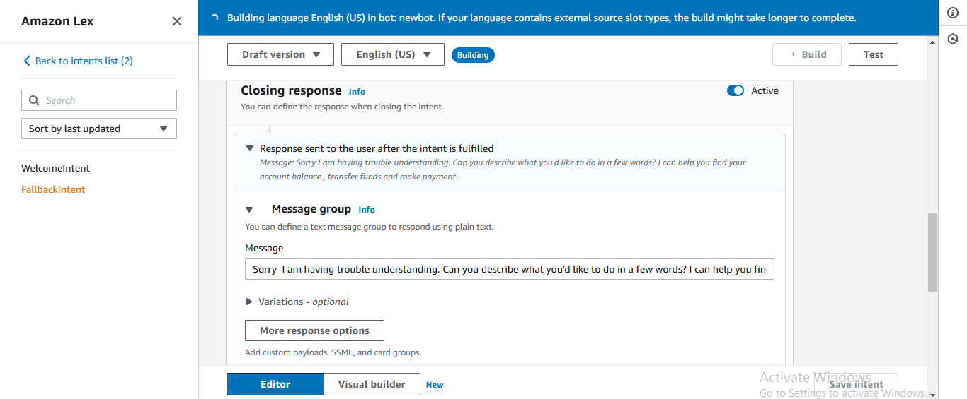

Choose test.

Try saying What’s good.

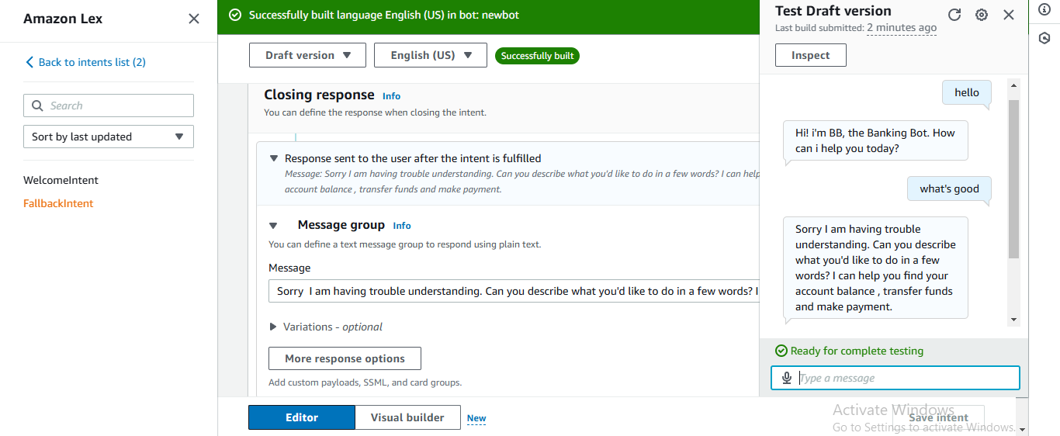

Time to clean up those resources - let's make sure we don't rack up any charges.

STEPS BELOW:

Head to your Amazon Lex console.

Choose Bots on the left-hand sidebar.

Choose the circle radio button next to BankerBot.

Choose Delete from your Action drop-down.

Choose Delete.

